I (current in A) = U (voltage in V) / (200 * 0.0063 Ohm)
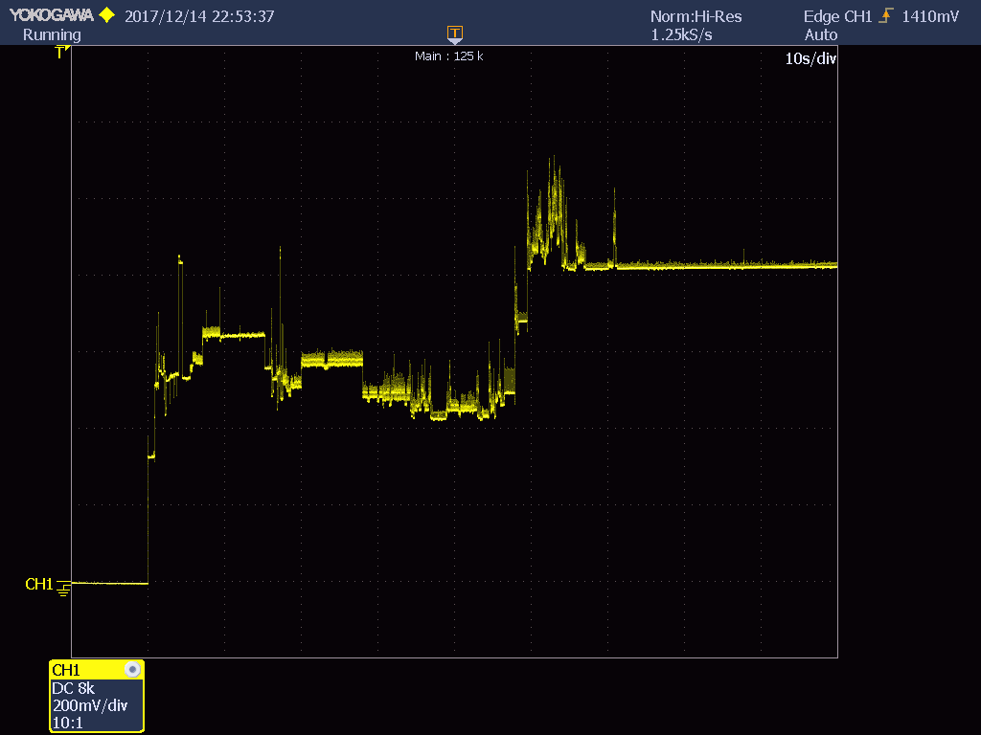
1. Powering and booting, max current 880mA, max power 2.9W
One division 200mV, 0.0063 Ohm resistor with 200V/V shunt amplifier, 3.3V voltage

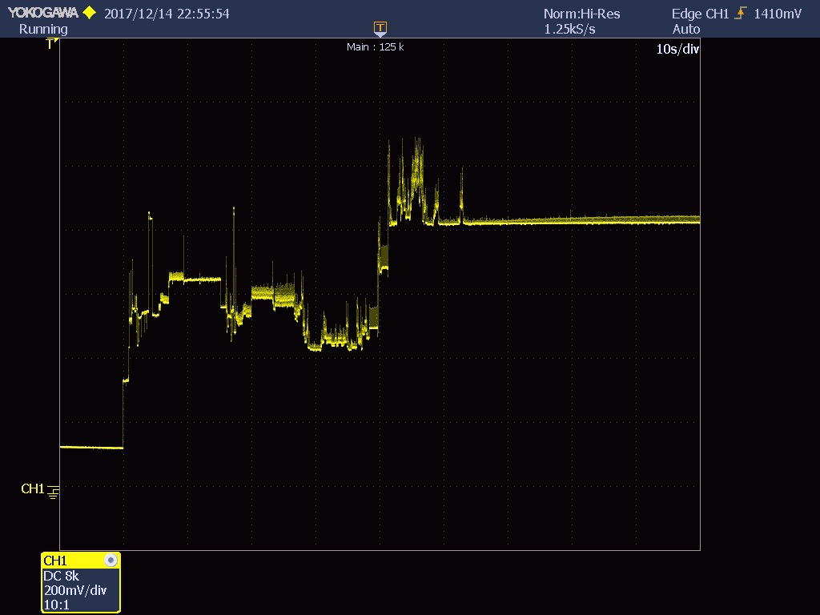
2. Releasing reset button and booting, max current 880mA, max power 2.9W
One division 200mV, 0.0063 Ohm resistor with 200V/V shunt amplifier, 3.3V voltage
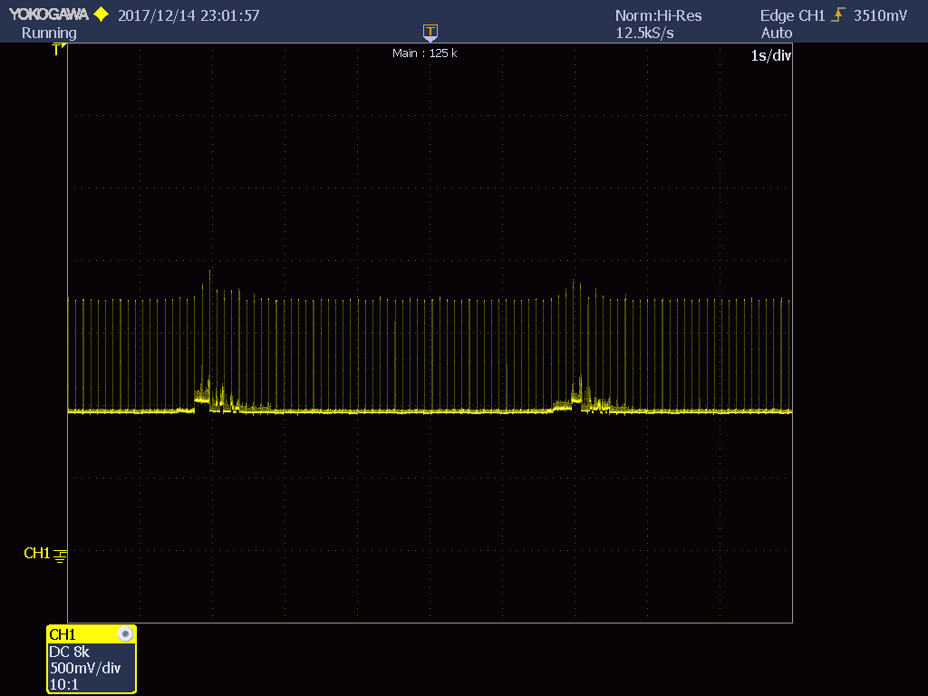
3. 2GHz Beacons. peak current 1530mA, peak power 5.1W
One division 500mV, 0.0063 Ohm resistor with 200V/V shunt amplifier, 3.3V voltage

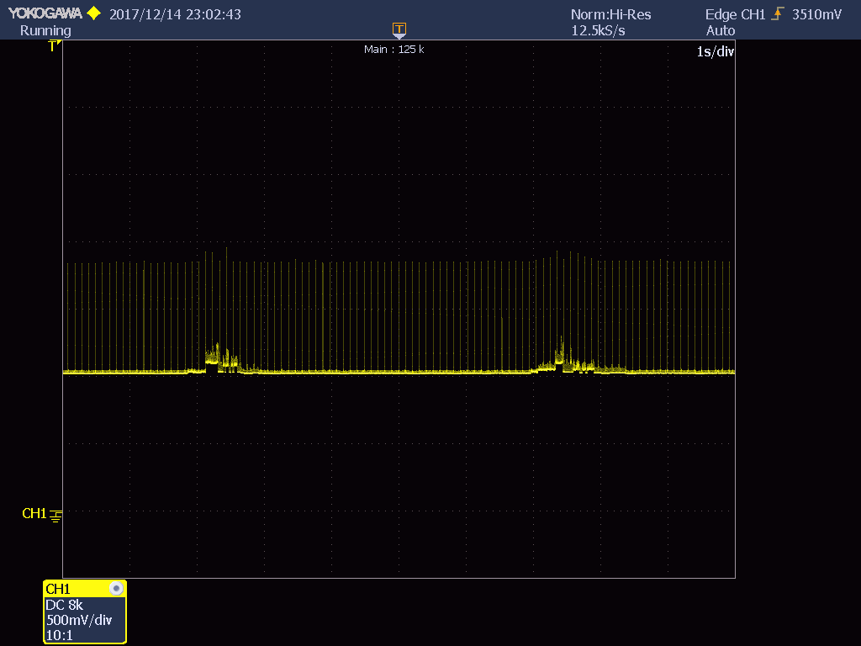
4. 5GHz Beacons. peak current 1530mA, peak power 5.1W
One division 500mV, 0.0063 Ohm resistor with 200V/V shunt amplifier, 3.3V voltage
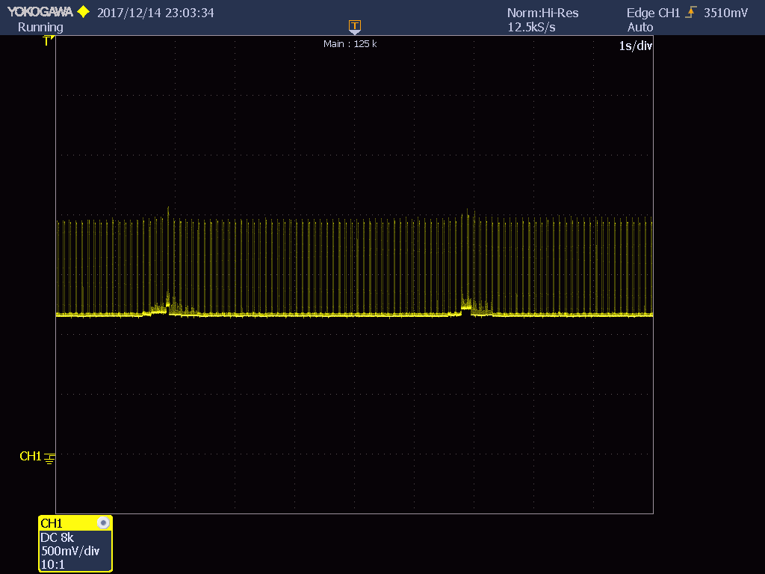
5. 2GHz & 5GHz Beacons. peak current 1610mA, peak power 5.3W
One division 500mV, 0.0063 Ohm resistor with 200V/V shunt amplifier, 3.3V voltage

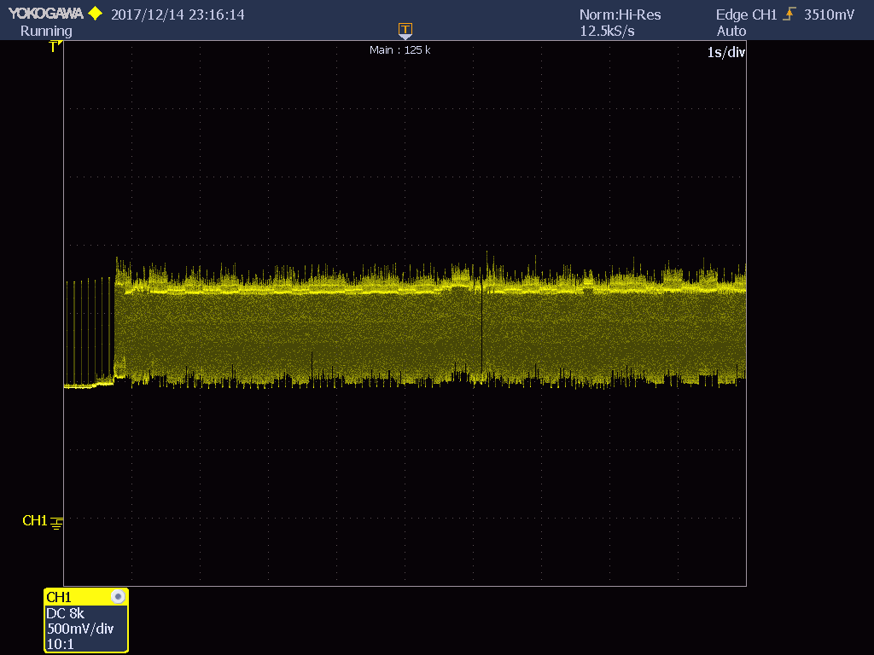
6. TX, 2GHz HT20, MCS7 MIMO 100Mbits/sec. max current 1530mA, max power 5.1W
One division 500mV, 0.0063 Ohm resistor with 200V/V shunt amplifier, 3.3V voltage
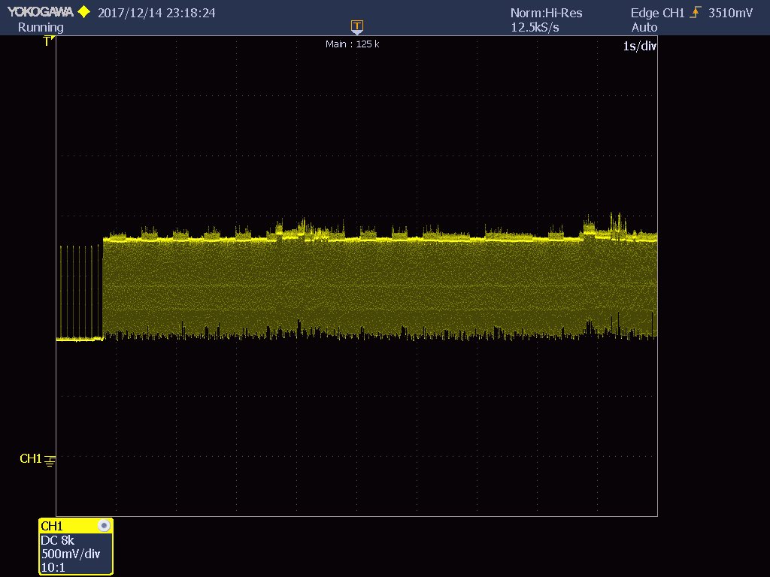
7. TX, 2GHz HT20, MCS0 MIMO 5Mbits/sec. max current 1570mA, max power 5.2W
One division 500mV, 0.0063 Ohm resistor with 200V/V shunt amplifier, 3.3V voltage

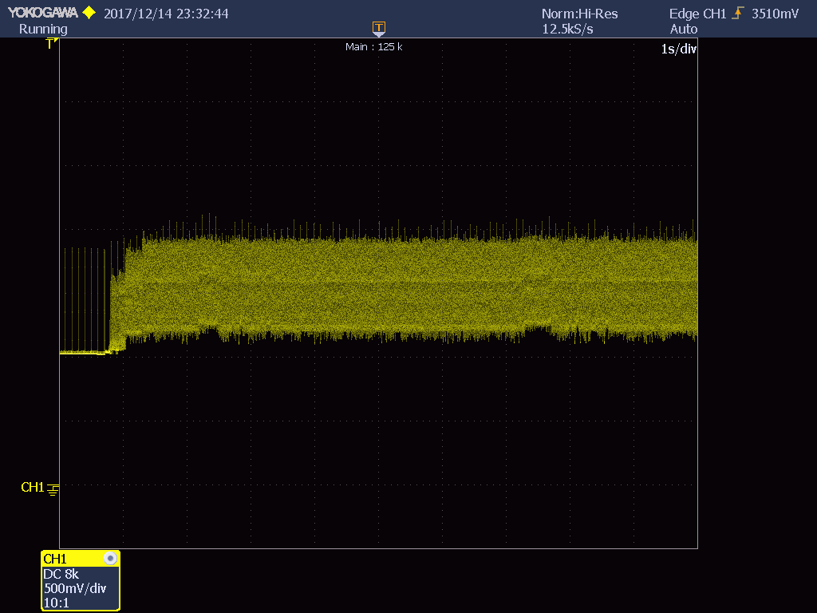
8. TX, 5GHz VHT80, MCS9 MIMO 200Mbits/sec. max current 1690mA, max power 5.6W
One division 500mV, 0.0063 Ohm resistor with 200V/V shunt amplifier, 3.3V voltage
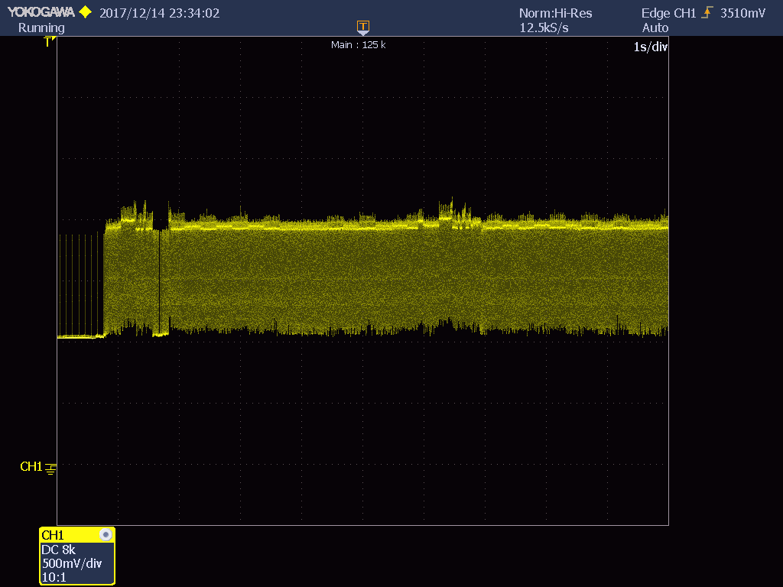
9. TX, 5GHz VHT80, MCS9 MIMO 45Mbits/sec. max current 1730mA, max power 5.7W
One division 500mV, 0.0063 Ohm resistor with 200V/V shunt amplifier, 3.3V voltage

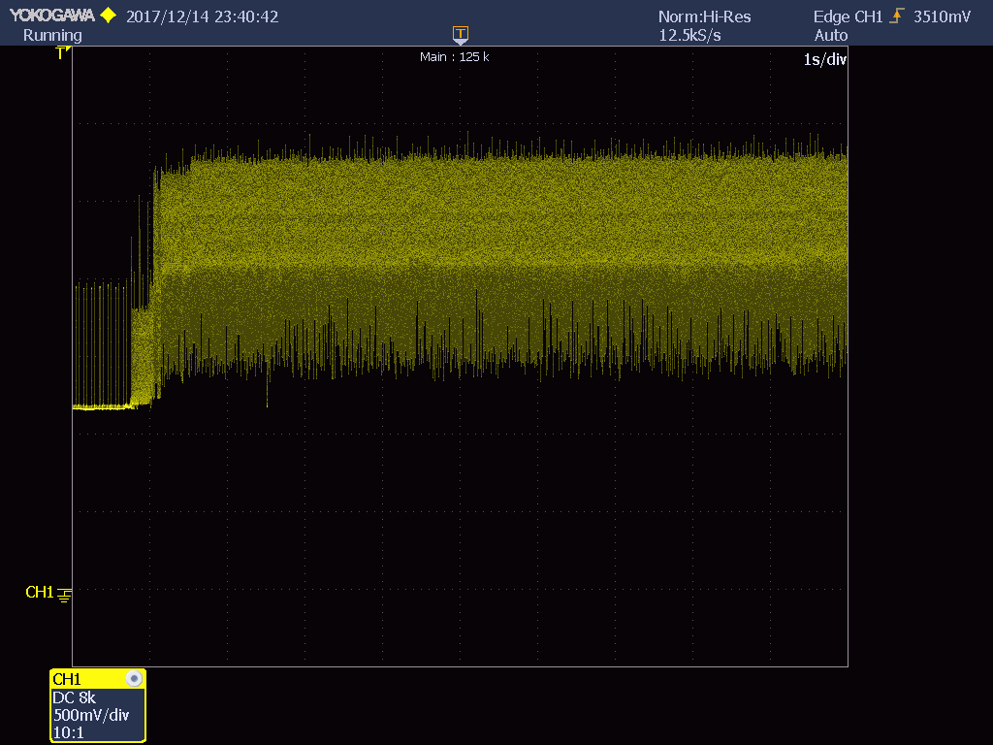
10. TX, 5GHz VHT80, MCS9 MIMO 200Mbits/sec. & 2GHz HT20, MCS7 MIMO 60Mbits/sec.
Max current 2.320mA, max power 7.7W
One division 500mV, 0.0063 Ohm resistor with 200V/V shunt amplifier, 3.3V voltage
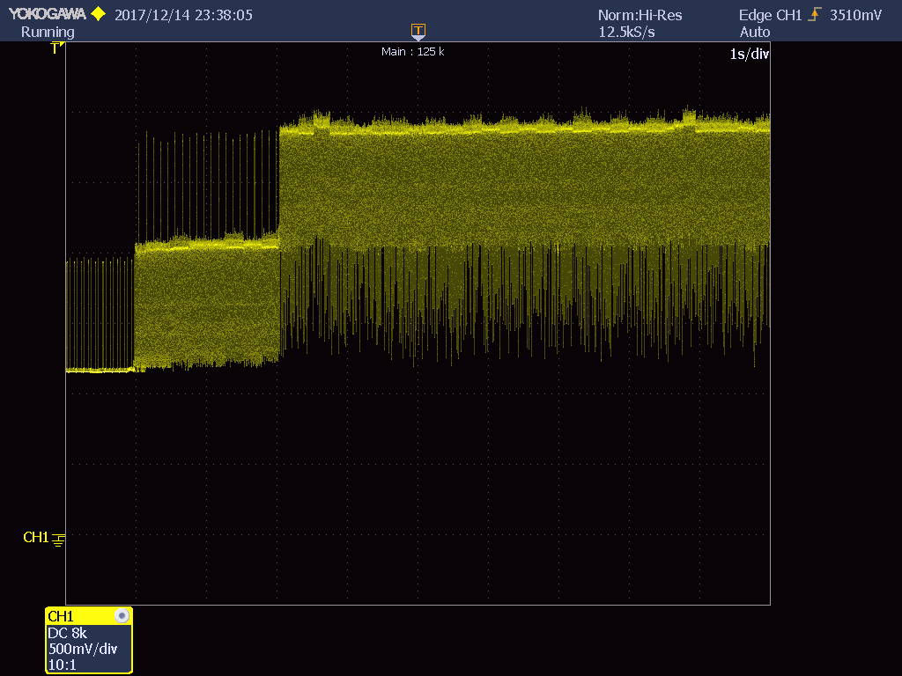
11. TX, 5GHz VHT80, MCS0 MIMO 45Mbits/sec. & 2GHz HT20, MCS0 MIMO 5Mbits/sec.
Max current 2.400mA, max power 7.9W
One division 500mV, 0.0063 Ohm resistor with 200V/V shunt amplifier, 3.3V voltage

