IMMEDIATE RELEASE

PH734
July 31, 2007

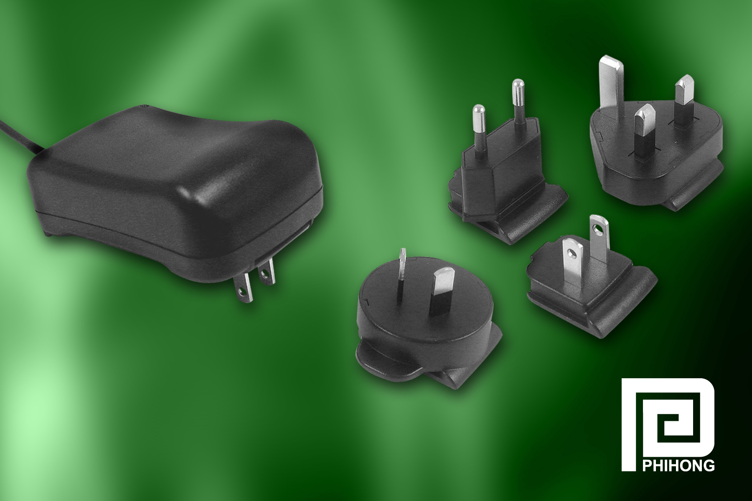
Cost- efficient adapter is CEC-compliant and compatible with outlets worldwide….

Phihong Develops 30W CEC-Compliant Adapter with Interchangeable Plugs

FREMONT, Calif. (July 31, 2007) — Phihong USA, the global leader in external power supplies, announces the expansion of its adapter line with a 30W version designed for worldwide use. Designated the PSC30R Series, the 30W adapter is available with four interchangeable clip adapter plugs for use in virtually any power outlet around the world. This worldwide adapter allows a single part number to be used, simplifying inventory controls and approvals.

“The PSC30R allows OEMs to simplify production and reduce costs by providing a product that is adaptable worldwide,” said Keith Hopwood, vice president of marketing for Phihong. This new series of adapters is ideal for applications involving point-of-sale equipment, test equipment, network equipment and battery chargers.

- more -

Phihong Develops 30W Adapter with Interchangeable Plugs, Pg. 2

The PSC30R Series adapter is a high-efficiency, class B EMI, limited power source that is competitively priced because only one adapter piece needs to be produced. This device also meets the requirements for Energy Star and CEC level IV.
The adapter measures 3.9 inches x 2.5 inches x 1.4 inches and weighs 9 ounces. It features a DC socket and low leakage current. The device is CEC-compliant and meets cUL/ UL, TUV, SAA, CE, and C-Tick safety approvals.
The 30W adapter features no-load power saving and a low leakage current of .25mA. AC input voltage ranges from 90VAC to 264VAC with short circuit protection and auto restart.
The AC clips are sold separately. PSC30R adapter is currently available from stock.

Phihong is the leading supplier of power and accessories to personal electronic, networking and home entertainment OEMs, supplying power, cradles, hands-free headsets, interface cables and virtually any accessory required for the personal electronic device. With global sales for 2007 expected to exceed $500 million, Phihong has engineering and manufacturing facilities in North and South America, Taiwan and mainland China. For more information contact Johny Chen, Phihong, 47800 Fremont Blvd., Fremont, CA 94538, or call (510) 445-0100, fax (510) 445-1678, email usasales@phihongusa.com, or visit http://www.codico.com.

