

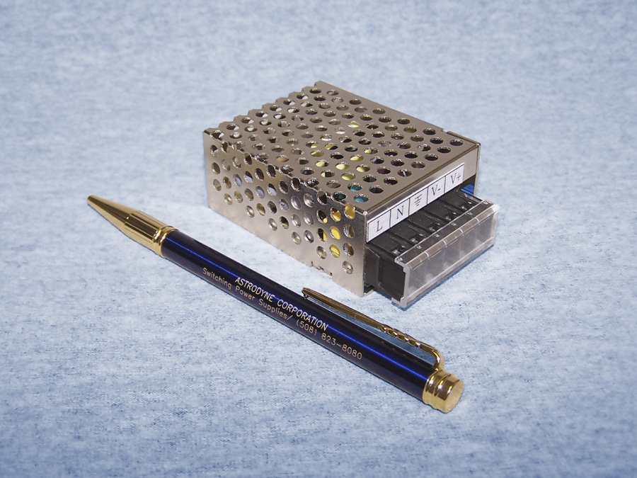

Economical Enclosed 15 Watt AC/DC Switching Power Supplies

90-264VAC Universal Input
Single Outputs from 5 to 48VDC
< 1U Profile
EN55022 Class B EMC

MANSFIELD, Mass., May 30, 2007 - Designed to meet the space and performance needs in low- power telecommunication, industrial control and embedded systems applications, Astrodyne announces the PV15 line of high density enclosed switching power supplies that provide 15 Watts of output power. All models accept universal input from 90-264VAC and 5 models are available that provide single outputs from 5VDC to 48VDC. All models feature integral EMI filtering for EN55022 Class B compliance.

The PV15 Series models feature an integral power-good LED indicator and output adjustment potentiometer and will operate over the ambient temperature range of -20° to +60°C without forced cooling or output power derating. All models contain overvoltage and short circuit protection circuitry. Dimensions are 2.59"L X 1.98"W X 1.1"H and all models feature screw terminal input/output connections.
ends

