Phihong’s 60W Midspan Powers
Wireless, WiMAX Access Points

Fremont, Calif.- (May 21, 2007) —Phihong USA, a global leader in Power-over-Ethernet solutions, has introduced a 60W midspan and a 52W PoE Gigabit high-power splitter specifically designed to support high-power wireless access points. Designated the POE60U-560G, the midspan is designed to power wireless access point arrays and WiMAX access points that require up to 52 watts of power. The POE60D splitter is a Gigabit-compatible device designed to be mounted right next to a powered device, performing connect identification function as well as separating the power and data. Both are designed around the current specifications of the proposed IEEE802.3at standards, and are ideal for implementing Power-over-Ethernet to power multi-radio access point arrays in business and educational environments.
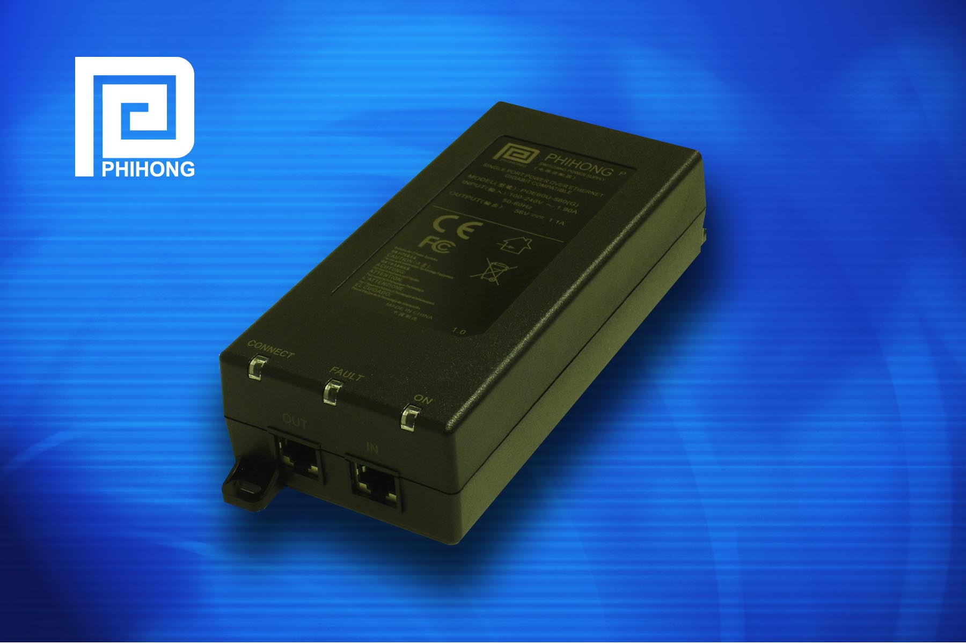
Midspans and splitters make high power access points more cost-efficient….

Phihong’s 60W Midspan Powers Wireless/WiMAX Access Points, Pg. 2

“Other solutions require hard-wiring power to the ceiling where the access points are mounted, which can cost hundreds or even thousands of dollars in labor costs. This new midspan and splitter can power those applications without a significant investment in time, labor and equipment.” In addition to wireless and WiMAX access points, applications for the POE60U midspans include computer workstations and electronic displays.

The POE60U Single-Port Midspan
The 60W midspan features diagnostic LEDs and the same safety and protection systems as with the IEEE 802.3af standard, including detection, disconnect and overload control. The device is also Gigabit-compatible.
DC output no-load voltage for the one-port midspan is 56V with accurate overload detection. The outputs are equipped with short circuit and overload protection, and the output can be shorted permanently without damage. The voltage range of the AC is 90VAC to 264VAC, and AC input frequency from 47Hz to 63Hz.
Phihong’s POE60U midspan has been tested for compatibility and broadband data handling capability by UNH IOL. Safety approvals for the 60W one-port device include cUL/UL and CE. Phihong is an expert at international safety agency approvals and can offer almost any international safety or EMC compliance standard.

The POE60D Splitter
The POE60D splitter, which features an LED indicator that signals whether the device is working properly, is also gigabit-compatible and makes it suitable for almost any application.
Available in a non-vented case with 10BASE-T, 100BASE-T, and 1000BASE-T data rates and a UNH IOL test report, the Power-over-Ethernet splitter features a non-isolated output voltage range of 51Vdc to 57Vdc. The device also has full OTP-, OCP-, and OVP-protection.

Phihong is one of the leading suppliers of power solutions to networking OEMs, including power supplies, adapters and Power-over-Ethernet products. With global sales for 2007 expected to exceed $500 million, Phihong has engineering and manufacturing facilities in North and South America, Taiwan and mainland China.
For more information contact Johny Chen, Phihong, 47800 Fremont Blvd., Fremont, CA 94538, or call (510) 445-0100, fax (510) 445-1678, email sales@phihongeu.com, or visit http://www.phihong.com.
###

