IMMEDIATE RELEASE, PH583
May 15, 2007

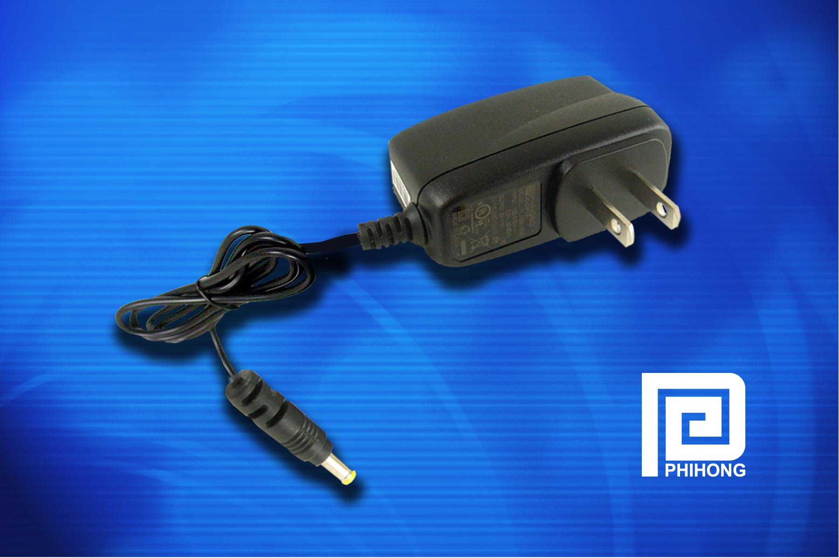
Linear replacement adapters provide energy-efficient alternative….

Phihong’s Universal Linear Replacement Adapter Line Meets CEC Requirements

FREMONT, Calif. (May 15, 2007) — Phihong USA, the global leader in external power supplies, has developed a series of linear replacement products designed as a low cost replacement for non-compliant linear adapters. Designated the PLA Series, the universal input California Energy Commission (CEC)-compliant products are very close in cost to linear adapters, but unlike those devices, the linear replacement adapters meet the latest energy regulations.
“Phihong is the only manufacturer offering a complete range of CEC-compliant adapters, and the only one making linear replacement adapters available as standard solutions to the general market,” said Keith Hopwood, vice president of marketing for Phihong USA. “While the new CEC regulations are forcing manufacturers to design alternatives to the linear adapters they are currently using, Phihong is doing it in support of our longstanding company-wide green initiative.”
- more -

Phihong’s Linear Replacement Adapter Line Meets CEC Requirements, Pg. 2
Phihong is able to offer its PLA Series linear replacement adapters at a lower cost than traditional switching adapters because they have eliminated the control and feedback circuits and components. Also, the adapter simply uses one primary control circuit. “The products have the benefits of a wide-range input switcher but the output regulation is more like a linear product,” Hopwood said.
The PLA Series devices are available as fixed wall plugs (1.3W, 2W, 3W, 5W). The PLA Series adapters feature high efficiency, double insulation and have short circuit protection with auto recovery. The devices have a no-load power consumption of less than 0.3W, zero minimum load, and meet the minimum efficiency required by Energy Star and CEC. Unlike linear adapters, these products have a wide input voltage range of 90VAC to 264VAC.
Phihong’s series of linear replacement adapters are RoHS-compliant, meet CEC (tier IV required for 2008) and Energy Star regulations as well as relevant worldwide safety and EMC requirements.

Phihong is one of the leading suppliers of power solutions to consumer electronics OEMs, including power supplies and external adapters. With global sales for 2007 expected to exceed $500 million, Phihong has engineering and manufacturing facilities in North and South America, Taiwan and mainland China.

