FOR IMMEDIATE RELEASE, PH562
October 5, 2006
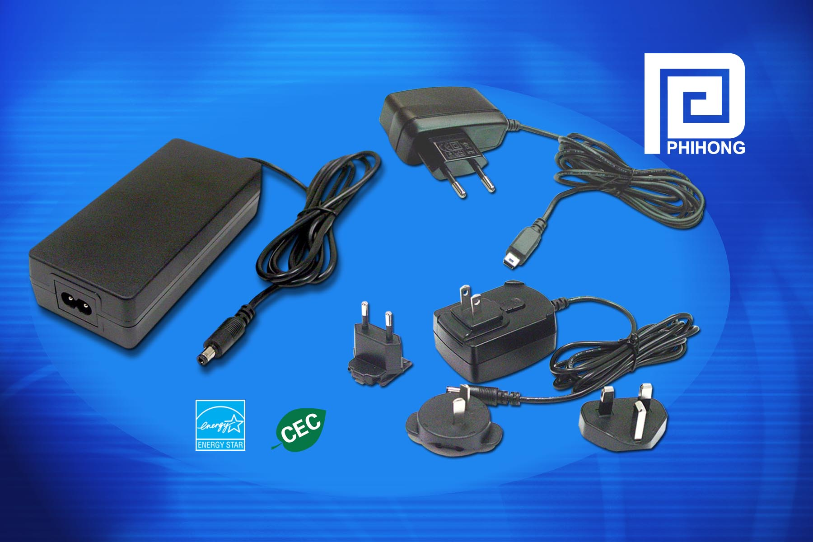

OEMs impacted by environmental regulations’ January 1st, 2007 deadline….

Phihong Offers A Wide Range of Adapter Models That Are CEC-Compliant

FREMONT, Calif. (October 5, 2006) — Phihong USA, the global leader in external power supplies, has released a complete line of desktop and wallplug adapters that meet the specifications for external power supplies as required by the California Energy Commission as of January 1, 2007. The company, which is active in many environmental programs and serves on a number of eco-oriented committees, has delivered products that meet the standard since 2004 when Energy Star developed standards for the best performing products.
“Our two main concerns were meeting the new standards without increasing cost, as well as doing it in a timeframe which would enable our customers to have their products and inventory ready and prevent them from having products they could no longer sell,” said Keith Hopwood, vice president of marketing for Phihong USA. “Many manufacturers are just now realizing that they need to make their products CEC-compliant to legally sell in California, Arizona and Washington by the mandated timeline or risk getting fined or risk having to recall and replace products. Our customers now have a full range of compliant products to buy compliant adapters so they are assured their products meet all requirements.”

- more -
Phihong Offers Wide Range of CEC-Compliant Adapters, Pg. 2

On December 15, 2005, the CEC adopted appliance energy efficiency standards for power supplies sold or offered for sale in California. Arizona and Washington have now also followed with legislation pending in New York State and several others. The standards, which were to take effect on July 1, have now been extended to January 1st, 2007 to give manufacturers time to implement compliant products. The standards apply to single-voltage external AC-to-DC or AC-to-AC power supplies, and among the specifications require a minimum efficiency and maximum standby power when unloaded. The efficiency level is calculated based on power levels. Maximum energy consumption in no-load mode must be 0.5W if the output is less than 10W and 0.75W if the output is between 10W and 250W.
Phihong has been active in promoting environmentally sound power products, adapting its product lines to meet RoHS, WEEE, EU Code of Conduct, China Energy Council, Canadian Standards, Australian and New Zealand MEPS, ENERGY STAR®, and Proposition 65 standards as well.
In January 2005, Phihong became the first manufacturer of external power supplies to be named a partner of the Environmental Protection Agency’s ENERGY STAR Program. On average, ENERGY STAR models are 35 percent more efficient than conventional designs, and often are lighter and smaller in size.
Phihong has also been recognized by the EPA as an early participant in the ENERGY STAR program and for the company’s involvement in helping the group develop energy standards and specifications for manufacturers that were aggressive but economically achievable.

- more -

Phihong Offers Wide Range of CEC-Compliant Adapters, Pg. 3

“We have long been committed to developing energy-efficient, environmentally-friendly power supplies because we believe that conforming to the new energy standards is the best way to do business now,” Hopwood said.
According to the CEC Web site (www.energy.ca.gov), the energy savings from the new standards over the next ten years will enable the state to avoid building three large power plants.
For more information on Phihong’s CEC-compliant power adapters, visit http://www.phihong.com/green.
Phihong is one of the leading suppliers of power solutions to networking OEMs, including power supplies, adapters and Power-over-Ethernet products. With global sales for 2006 expected to exceed $450 million, Phihong has engineering and manufacturing facilities in North and South America, Taiwan and mainland China.

