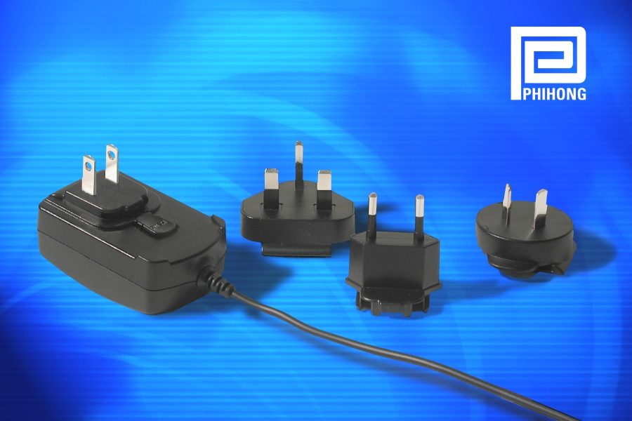
FOR IMMEDIATE RELEASE, PH219
January 30, 2004

For more information, contact:
Ka Yue Kwok, Phihong
(510) 445-0100
kwok@phihongusa.com

Paige Parker, BtB Marketing
919-872-8172
paige@btbmarketing.com

Unique 10-watt adapter reduces inventory and agency approvals for lowest cost in its class…

Phihong Offers Expanded Line of R-Series Power Adapters at a Highly Competitive Price

FREMONT, CA (January 30, 2004) — Phihong, the global leader in low cost power electronic accessories has reduced cost of its 10-watt interchangeable plug power adapters. The redesigned PSM-11R Series adapters, provide a low-cost, high-quality alternative to conventional fixed blade adapters for designers of OEM electronic equipment.
Not only are these adapters cost competitive with conventional fixed blade adapters, but because only one top assembly part number is required, they reduce the cost of stocking multiple finished items for various geographic destinations. In addition, conventional fixed blade adapters require test, approval and evaluation. By taking one product through this process, instead of the typical 4-5 different versions, development time and cost is significantly reduced.

- more -
Phihong Offers Interchangeable clip Adapters at Competitive Price, Pg. 2

Phihong is able to offer the new R-Series adapters at this highly competitive price due to design improvements that reduce the cost penalty for an interchangeable solution. Phihong is a leader in this technology and has spent years developing the product to be safe, low cost and accepted and approved by international safety agencies. Phihong currently holds several patents on the interchangeable clip technology.
“This power supply is attractive for global OEMs because they only have to stock one adapter with replaceable power plugs instead of different power converters, or for desktop systems that need multiple cords for each country,” said Keith Hopwood, vice president of marketing for Phihong USA. “Our innovative engineering capabilities and global manufacturing networks allow us to expand the R-Series line to 10-watts and reduce the price on this popular product even further. Additionally, this greatly simplifies the international approval process of products designed for the global market.”
The universal input and interchangeable clip adapter plugs enable the power supply to be connected to virtually any power outlet in the world and simplifies inventory and approvals with a single part number. Featuring <0.3W no load power consumption, the R-Series is ideal for applications such as lightweight portable electronic products including PDAs, digital cameras, MPEG players and other personal electronic devices.

- more -
Phihong Offers Interchangeable Clip Adapters at Competitive Price, Pg.3
The double-insulated adapter meets international agency certification and achieved ECOC (European Commission Code of Conduct) compliance ahead of schedule. The device is safety approved to UL1950 as well as CE (LVD and EMC), PSE, TUV and cUL requirements. The unit meets FCC class B and EN55022B conducted and radiated emission limits, and leakage current is less than 20uA at 250VAC 50Hz.
Smaller than a business card and weighing only 4.5 oz. (less than a typical hand-held calculator), the PSM-11R adapter features universal input, allowing it to operate for any worldwide line voltage from 90 to 264VAC. Various models provide a single output ranging from 5V to 12V.
The PSM-11R measures just 2.8" x 1.8" x 1.2". It includes a 70-inch cable with a center-positive 2.1mm barrel connector.
The product is available off-the-shelf from Phihong’s authorized distributors.
Phihong is the leading supplier of power and accessories to personal electronic OEM’s supplying power, cradles, hands-free headsets, interface cables and virtually any accessory required for the personal electronic device. With global sales for 2004 expected to exceed $400 million, Phihong has engineering and manufacturing facilities in North and South America, Taiwan and mainland China. For more information contact Ka Yue Kwok, Phihong, 47800 Fremont Blvd., Fremont, CA 94538, or call (510) 445-0100, fax (510) 445-1678, email usasales@phihongusa.com, or visit http://www.phihong.com.
###

To request the electronic image, call 919-872-8172, or e-mail paige@btbmarketing.com

