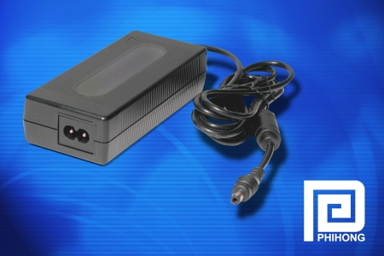

Compact size combines with high efficiency for LCD TV and networking applications….

Phihong 80W External Adapter Provides
87 Percent Efficiency

TIVERTON, U.K. (January 3, 2005) — Phihong, the global leader in low cost power supplies, introduced its new PSA80W adapter, specifically designed for LCD TV, home entertainment, networking and gaming applications. The universal input adapter is an external power supply that decreases heat through an ultra-high efficiency topology in a tiny, low-profile package that meets the new EPA ENERGY STAR® standard for external power supplies.
The PSA80W delivers up to 80W of power with 87 percent efficiency (EPA ENERGY STAR measurement), the highest on the market. It also meets European ECOC standards and proposed California Energy Commission requirements.
“The PSA80W provides a lot of power in a tiny size yet still remains cool and highly reliable. This makes it a very attractive ergonomic solution for consumers and OEMs,” said Keith Hopwood, vice president of marketing for Phihong USA. “The power supply’s high efficiency design minimizes heat dissipation and has allowed us to reduce the volume by over 50 percent from previous generations of similar product.”
- more -
Phihong Intros 80W Power Adapter For LCDs and Networking, page 2

Available in standard two-wire C8 input (or optional 3-wire C6 grounded input) with a universal input from 100VAC to 240VAC, the PSA80W is available in 12V, 16V and 24V versions. The compact unit measures 5.12 x 2.20 x 1.22 inches and weighs less than a pound.
In addition to meeting ENERGY STAR and ECOC standards, the PSA80W is approved and listed by cUL, TUV and CE for IEC60065 and IEC60950 safety approvals.
More information is available on the web site, at www.phihong.com.
Phihong is the leading supplier of power solutions to networking and personal electronic OEMs supplying custom power supplies from 10-1.5kW, power adapters and PoE injection solutions. With global sales for 2004 expected to exceed $350 million, Phihong has engineering and manufacturing facilities in North and South America, Taiwan and mainland China.
For more information contact Steve Smith, Phihong Europe, Swallow Court, Suites 3 & 4, Devonshire Gate, Tiverton, EX167EJ, England, or call +44 (0) 1884 849300, email steves@phihongeu.com or visit http://www.phihong.com.
###

To request the electronic image, call 919-872-8172, or e-mail patricia@btbmarketing.com.

