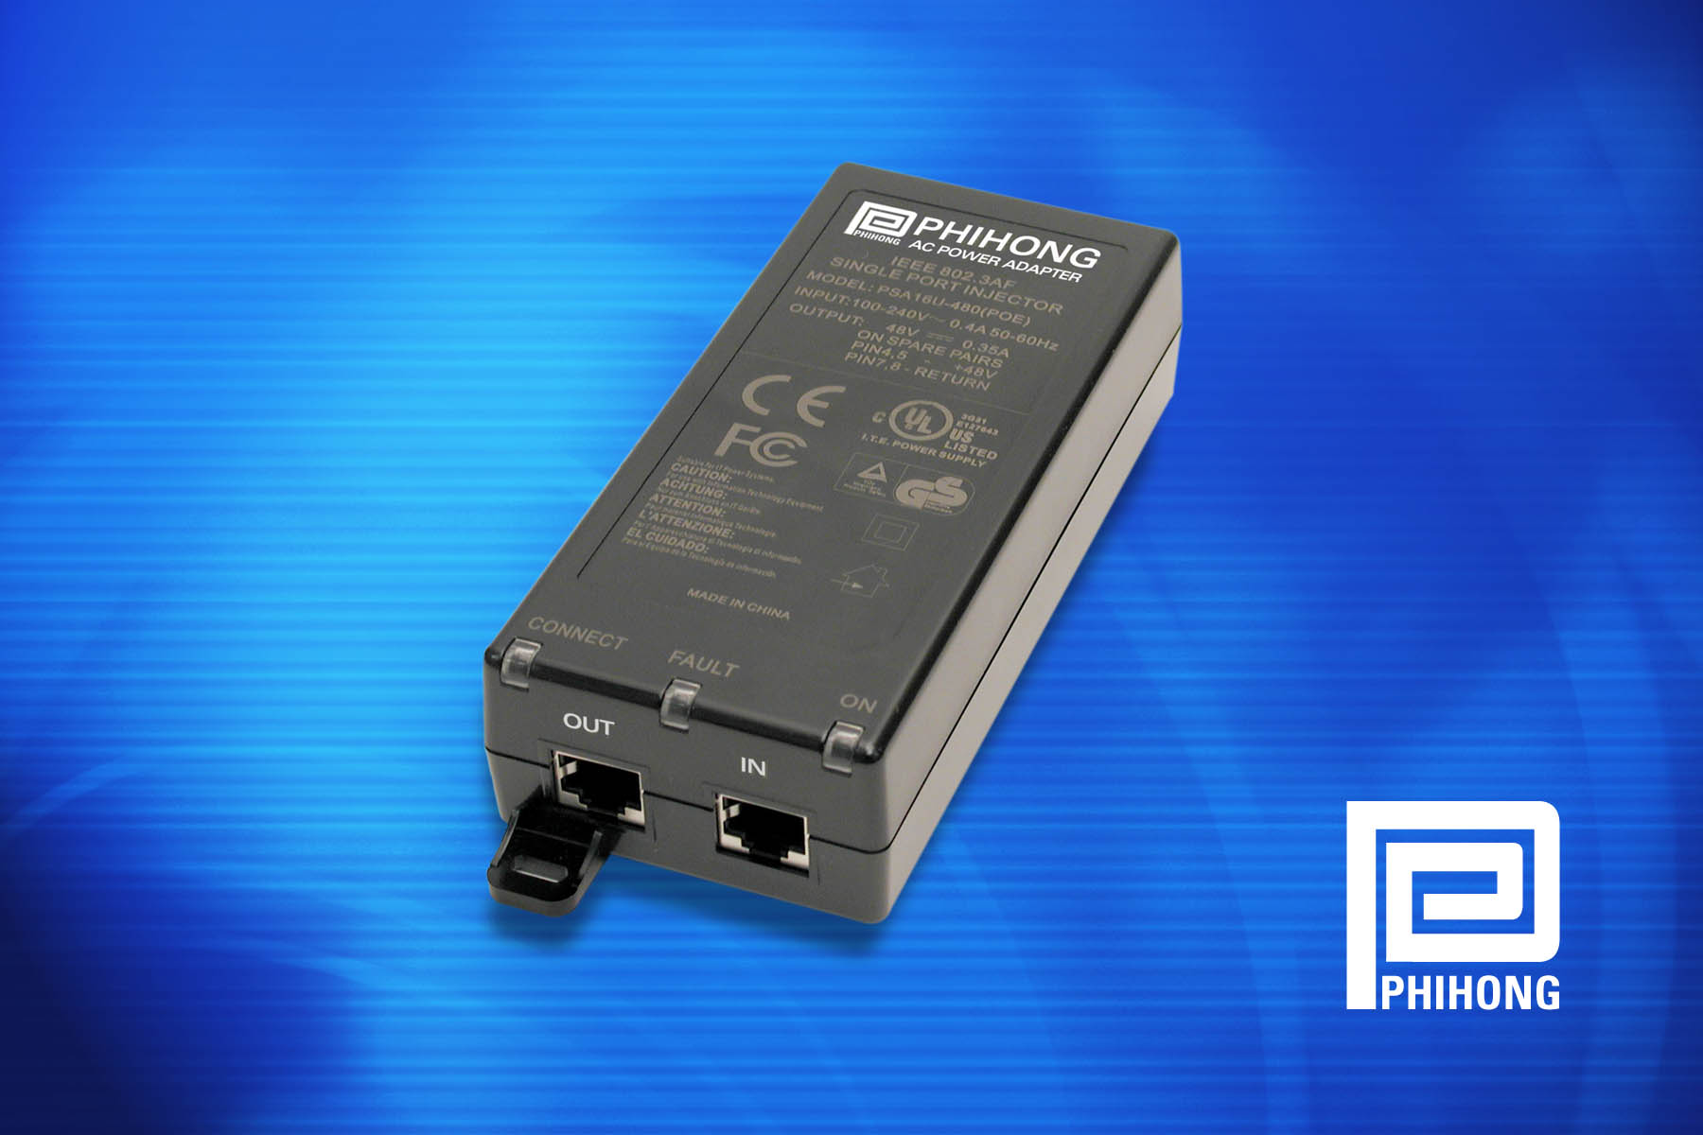

Single port injector from Phihong offers low cost solution to PoE technology…

Phihong Develops IEEE802.3af-Compliant Power-over-Ethernet Single Port Injector

TIVERTON, U.K. (June 14, 2004) — Phihong, the global leader in low cost power supplies, recently introduced its single port power injector for Power-over-Ethernet (PoE) applications, including wireless access points, security cameras and IP telephones. Designated the PSA-16U switching power supply, Phihong’s device is one of the only single port injectors to fully comply with the new international standard, IEEE802.3af.
Power-over-Ethernet technology is an innovative solution to problems involving AC power and the placement of power outlets. PoE allows both power and data to be carried over one Ethernet cable. An access point can operate entirely from the power it receives through the data cable.
- more -
Phihong Develops IEEE802.3af-Compliant PoE Single Port IC, Page 2

“There are significant cost savings associated with implementing a PoE system for wireless access points,” explained Keith Hopwood, Vice President of Marketing for Phihong USA. “Installing local power outlets in a warehouse, store or office can cost hundreds of dollars and cause delays due to scheduling for an electrician. Moving or installing an Ethernet cable doesn’t carry any of these limitations; PoE allows for more flexibility in warehouse and/or office layouts and security camera locations.”
By supplying power and data through one cable, security cameras that are located outside do not need an additional “wet location” power supply installed. Office design becomes more flexible using PoE because IP phones can operate on one Ethernet cable and do not require additional power cables. Phihong offers modified solutions that will also connect with legacy IP phones and access points using capacitor or loop-back detection.
“There are several ‘so-called’ solutions on the market today that claim to offer PoE compatibility, but many are simply dumb injectors or non-compliant,” continued Hopwood. “Using these other solutions can be potentially dangerous, causing damage to the system, and they do not guarantee interoperability. Designers can avoid all of these pitfalls by using devices that meet the IEEE802.3af standard.”
AC input voltage range for the single port injector is 90VAC to 264VAC with voltage range from 100VAC to 240VAC and AC input frequency from 47Hz to 63Hz. Maximum output load current is 0.35A and O/P voltage is +48VDC. The device offers total output power of 15.4W with fully compliant detection, connection, disconnection and fault protection per the IEEE standard.
The adapter features 3 LEDs that indicate power, connection and faults to ease installation and set-up. Safety approvals for the PSA-16U include cUL, TUV and CE double insulated class 2. Approvals for EMI are EN55022 Class B, FCC part 15 Class B. Phihong is an expert at international safety agency approvals and can offer almost any international safety or EMC compliance standard.
- more -
Phihong Develops IEEE802.3af-Compliant PoE Single Port IC, Page 3
Parts are available immediately. More information is available on the web site, at http://www.phihong.com/html/poe.html.
Phihong is the leading supplier of power solutions to networking and personal electronic OEMs supplying custom power supplies from 10-1kW, power adapters and PoE injection solutions. With global sales for 2004 expected to exceed $350 million, Phihong has engineering and manufacturing facilities in North and South America, Taiwan and mainland China.
For more information, contact Steve Smith, Phihong Europe, Swallow Court, Suites 3 & 4, Devonshire Gate, Tiverton, EX16 7EJ, England, or call +44 (0) 1884 849300, email steves@phihongeu.com or visit http://www.phihong.com.

###

To request the electronic image, call 919-872-8172, or e-mail paige@btbmarketing.com

Keywords : Phihong, PoE, Single Port, IEEE802.3af, Low cost
URL Link : http://www.phihong.com/html/poe.html

