Modular AC/DC power supply uses innovative architecture –
sets new performance standards for user-configurable products
- 1U-high powerPac & plug-in powerMod DC output modules suit medical/industrial/data/telecom systems
- Unprecedented, industry-leading 15W/in³ power density and 90% conversion efficiency
- Plug-together architecture facilitates ‘instant’ custom power solutions

October 4, 2004 — Today, Excelsys Technologies launches a new generation of modular AC/DC power supplies believed to be the highest-efficiency and highest power density configurable products in the world. Known as the Xgen series, the power supplies employ an innovative architecture, based on a master AC/DC powerPac and multiple plug-in DC/DC powerMod output modules.

Xgen power supplies are designed specifically for fast user configuration in the development laboratory or field. Users simply select a powerPac with the appropriate power rating and plug in the powerMods to provide the DC voltages and currents they require. The ability to configure a custom power supply – using standard off-the-shelf modules – brings unprecedented flexibility to system designers and OEMs, enabling them to dramatically shorten development lead-times, reduce implementation costs, and accelerate maintenance.

According to Seamus Devitt, MD of Excelsys Technologies, “The Xgen series is the most significant product line we have ever launched, and will fundamentally change expectations in the OEM power supply market. Instant availability of custom power supplies has always been a holy grail to the industry, but it is only now that we have the necessary technology to bring this capability to the lower volume end of the market with the highest-spec product in the industry. Xgen capitalises on research we conducted for our previous-generation 3gen supplies, and is also the culmination of a further two years’ intensive development effort.”

At launch, the Xgen series comprises four AC/DC powerPacs, with ratings of 400, 700, 1000 and 1200 Watts, and eight plug-in powerMod DC output modules. The range of powerMods covers DC output voltages from 1.5 to 58V and includes single- and dual-output versions, as well as units capable of delivering up to 50A output current. Each powerPac accommodates up to six powerMods, which can be fitted in any combination the user chooses, with the simple proviso that their total power output must not exceed the powerPac’s power capacity. The entire process takes less than five minutes and requires no special skills. The ability to mix-and-match powerMods, and change them at will, gives developers considerable design freedom and enables them to handle any last-minute supply changes very easily and quickly – which until now has been impossible with conventional custom power supplies.

Each Xgen AC/DC powerPac measures just 260 x 127mm and has a very low profile of 40.4mm, making the power supplies ideal for use with the latest 1U-high rack-mount equipment. The powerPacs feature a universal input that accommodates 85 to 264VAC (47 to 63Hz) and 120 to 380VDC, enabling them to be used virtually anywhere in the world. Comprehensive built-in EMI filtering ensures that the units meet rigorous international EMC specifications, including EN55011, EN55022 and FCC level B for conducted and radiated emissions and EN61000-4-x level 3 for immunity to conducted and radiated RFI, electrostatic discharge, fast transients, line surges and voltage dips.

The powerPacs employ an advanced synchronous rectifier based converter topology with current shaping to provide power factor correction, and generate a relatively high internal DC bus voltage to supply all the powerMods. This approach maximises the conversion efficiency of the overall system, and contributes to its very high power density of more than 15 Watts/in³. For example, a power supply comprising a 1200W powerPac fitted with four 24V@12A (288W) powerMods has a typical full load efficiency in excess of 90%, when operating from a 230V input. The powerPacs are fitted with field replaceable cooling fans and are rated for full power operation over an operating temperature range of -20 to +60˚C; they can also be used up to 70˚C, with derating. Remote alarm signalling is optionally available, covering AC input failure, fan failure and over-temperature conditions.

Xgen series powerMods make extensive use of planar magnetics and surface-mount components, which help keep the size down to just 80 x 36 x 12mm, and employ high efficiency DC/DC conversion techniques to minimise power losses. The output voltage of each module can be adjusted over a wide range, via a screwdriver adjustable potentiometer, or remotely using a resistive divider or voltage reference source. An indicator LED simplifies field maintenance by confirming that the module is operating within normal ratings. Output modules can be connected in parallel for increased current, or in series for increased voltage, simply by using standard cross-connect links.

Every Xgen series powerMod provides better than ±0.1% line and ±0.2% load regulation, and holds output ripple and noise to less than 1% pk-pk. Transient response performance is equally impressive: the output voltage will deviate by less than 10% for a 25% to 75% step change in load current, and will fully recover in under 250µs. Most of the single-output modules offer remote sense capabilities as standard, to compensate for voltage drops in the power leads. Many of the modules also offer a remote enable input and a ‘power good’ output signal.

All Excelsys Xgen series power supplies have a 3000VAC input/output isolation rating and carry a full set of international safety approvals, including EN60950 and UL1950. The supplies are also available in medically approved versions, with 4000VAC input/output isolation and low leakage current, which meet the EN60601-1 and UL60601-1 standards. In addition to supplying customers with component parts, Excelsys is also able to deliver OEM quantities of fully configured Xgen power supplies with exceptionally short lead times, from its manufacturing facility in the Czech Republic.

Xgen is designed specifically for low to medium volume applications in medical, industrial, data and telecom applications where efficiency, size, low-cost and rapid availability are all important criteria. 100-off prices range from €200 depending on configuration.
ends

Photography available:

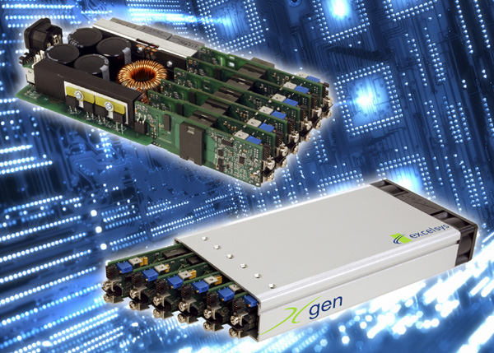 | Excelsys Technologies’ new Xgen series user-configurable AC/DC power supplies set new industry standards for efficiency and power density.  Download a 300dpi JPEG image from http://www.wordsun.com/exc05.jpg

Background information for editors

Excelsys is a fast-growing technology company that specialises in the design, manufacture, sales and support of innovative switch-mode power supplies for the OEM markets. Excelsys was founded in March 2000 through the acquisition of Delaire Power Products, a company with a 20-year track record in the power supply industry. Excelsys is based in a modern 1500m² facility on the outskirts of Dublin, Ireland, where it operates an ISO9001 certified plant for prototype and pre-production manufacturing. Volume manufacturing is sub-contracted to ISO9000 certified assembly specialists in the Czech Republic.

For more information about Excelsys and its products, please visit the company’s web site at http://www.excelsys.com

